|  |  |  |  |
| --- | --- | --- | --- |
| **S.**  **No.** | **Practical Outcomes (PrOs)** | **Unit No.** | **Pg**  **No.** |
| 1 | Create and Manage Files & Folders | I | 02 & 03 |
| 2 | Configure browser settings and use browsers. | II | 04 |
| 3 | Create and Manage Files and Folders in Google Drive | II | 05 |
| 4 | MS-Word: Create and Design Admission/Enquiry Forms for Students: use shapes, text boxes, colors, formatting options, tables, and horizontal lines etc. | III | 06 |
| 5 | MS-Word: Create bills/brochures for Company: Use Insert menu option, text adjustment between the table, page size, text boxes | III | 07 |
| 6 | MS-Word: Use smart art and create organization charts | III | 08 |
| 7 | MS-Word: Design E-book cover pages / Magazine front/ books front/back page: Header & Footer | III | 09 & 10 |
| 8 | MS-Word: Design a Happy Birthday Message by using Word Art and print it. | III | 11 |
| 9 | MS-Word: Design Newspaper advertisement: Use high-quality images, text, and layout | III | 12 |
| 10 | MS-Word: Create a chart and show the Results comparison between 2019, 2020, and 2021 | III | 13 |
| 11 | MS-Word: Create Letter Head | III | 14 |
| 12 | Google document: Create Google Document for Resume | II | 15 |

PROGRAM 1

CREATE AND MANAGE FILES AND FOLDER

1. Creating a folder

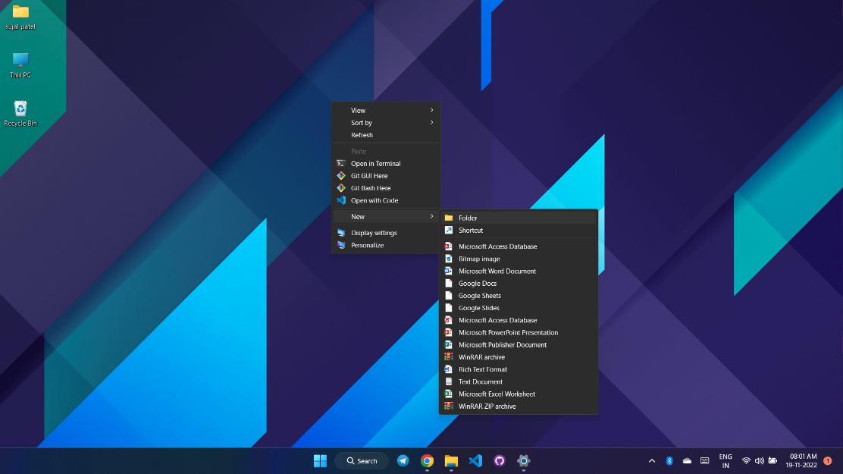

1. Renaming a folder

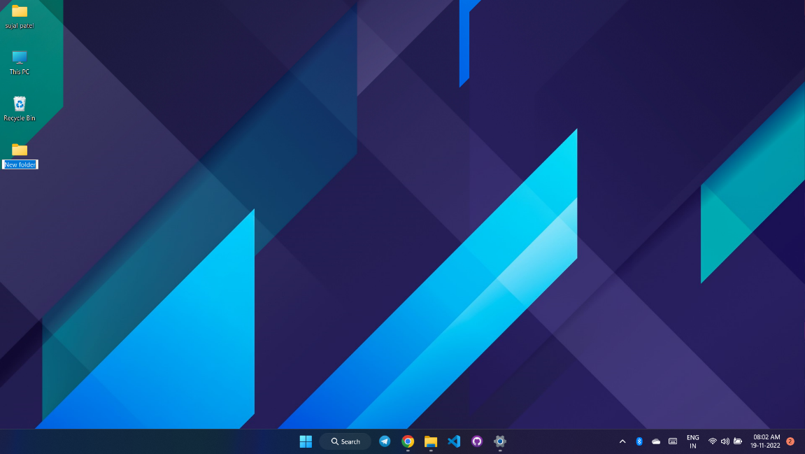

1. Create a new file

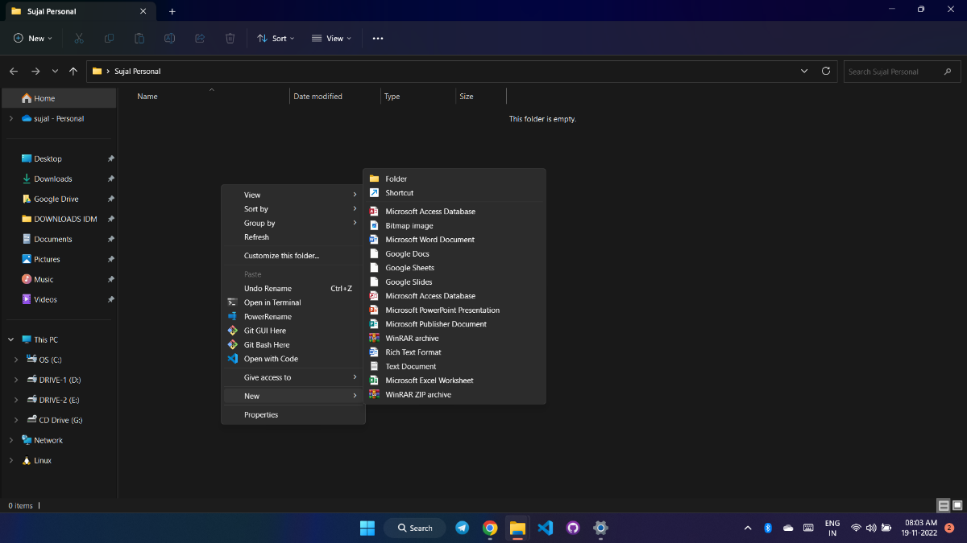

1. Moving files into a subfolder using drag and drop

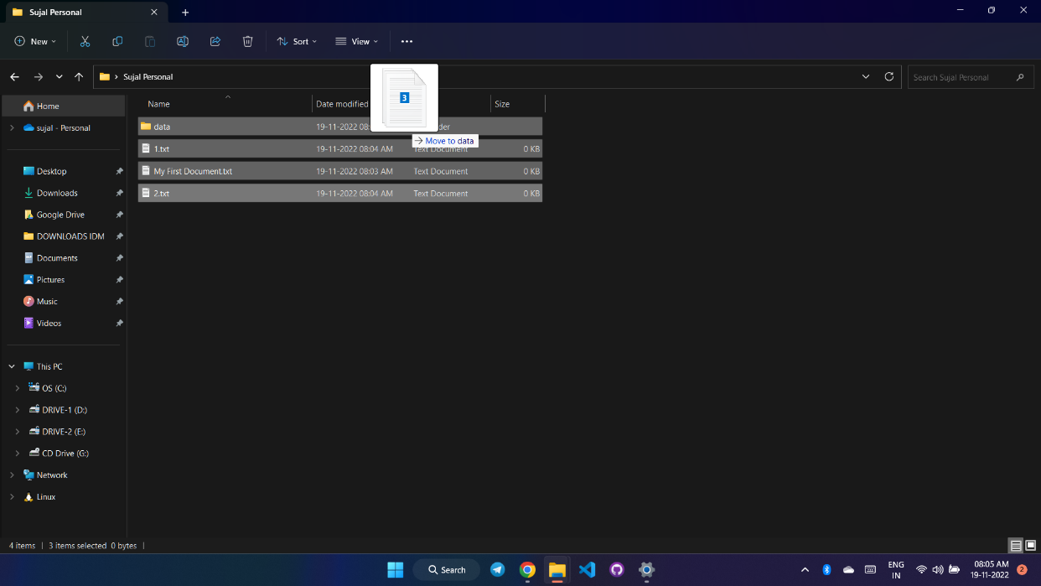

PROJECT 3

CONFIGURE BROWSER SETTINGS AND USE BROWSERS

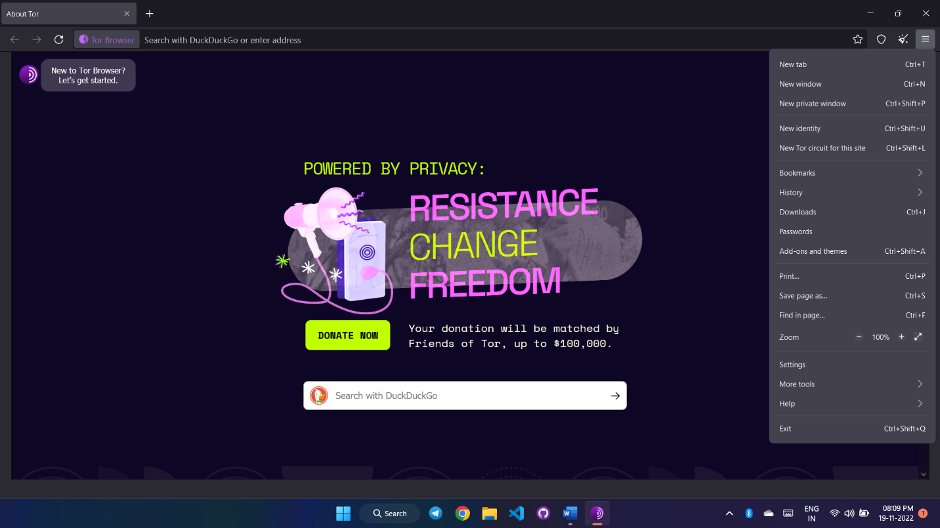

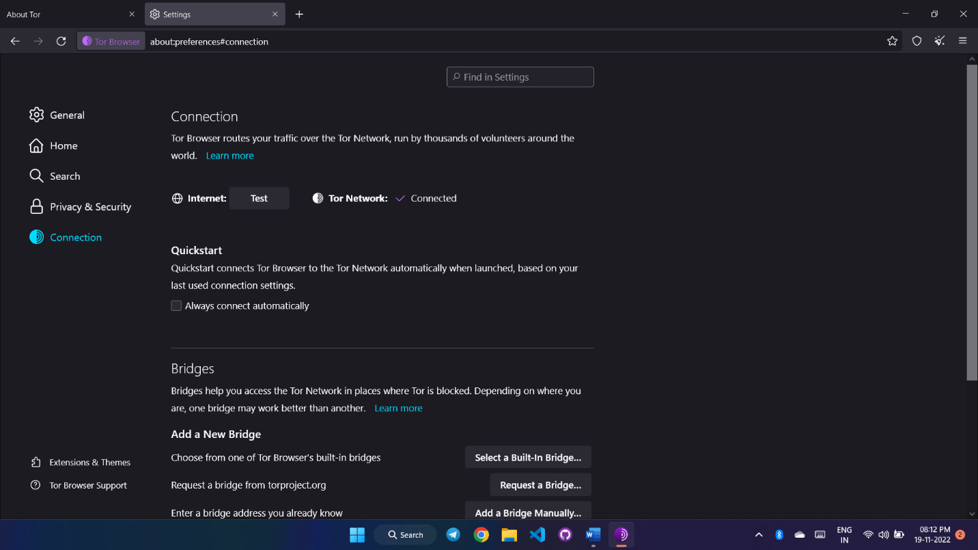

PROJECT 4

CREATE AND MANAGE FILES AND FOLDER IN GOOGLE DRIVE

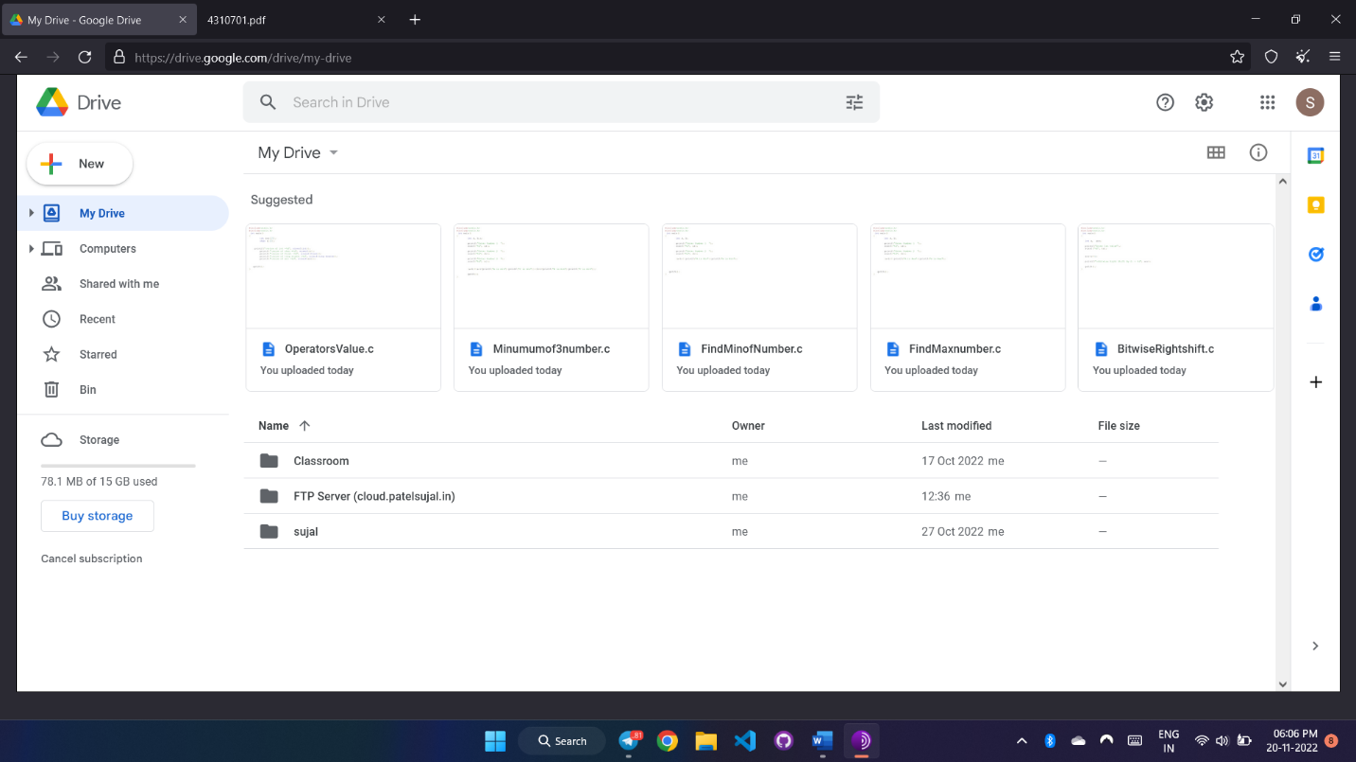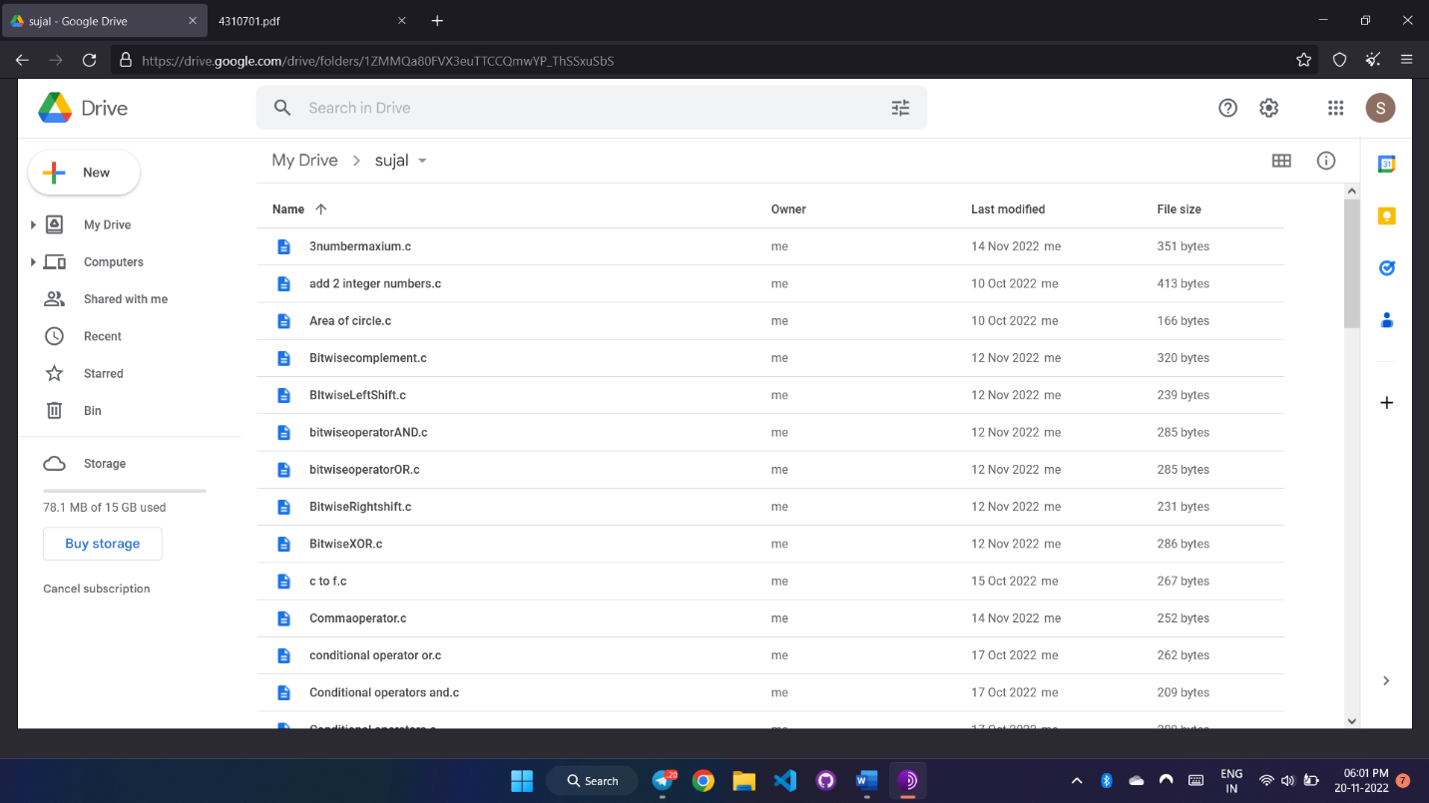

PROJECT 5

CREATE AND DESIGN ADMISSION/ENQUIRY FORMS FOR STUDENTS :

USE SHAPES, TEXT BOXES, COLOURS, FORMATTING OPTIONS, TABLES AND HORIZONTAL LINES ETC

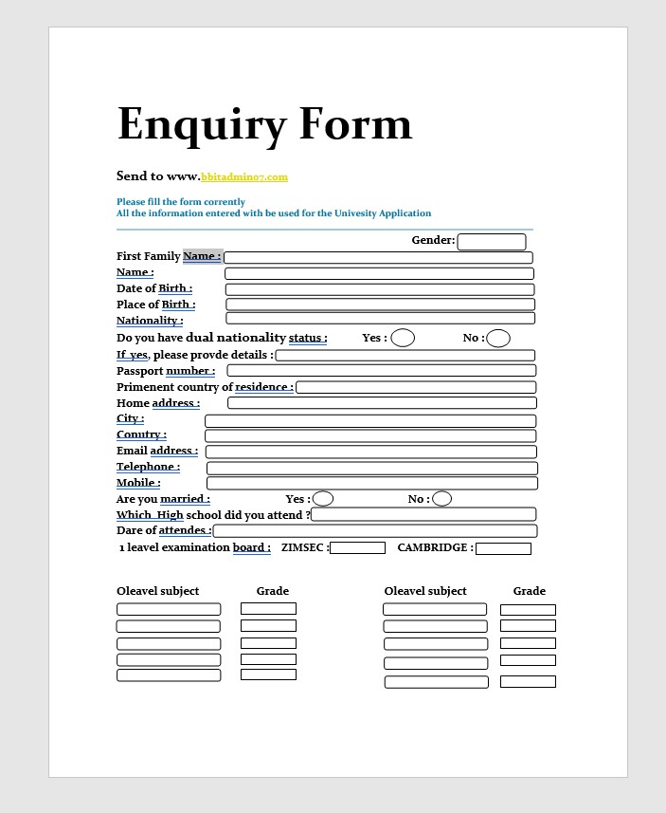

PROJECT 6

CREATE BILLS/BROCHURES FOR COMPANY: USE INSERT MENU  
OPTION, TEXT ADJUSTMENT BETWEEN THE TABLE, PAGE SIZE, TEXT BOXES

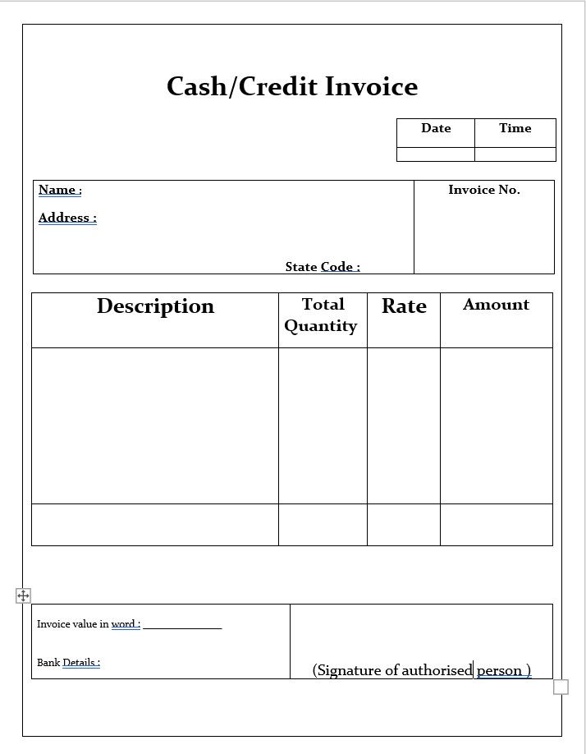

6PROJECT 7

USE SMART ART AND CREATE ORGANIZATION CHARTS

PROJECT 8

DESIGN E-BOOK COVER PAGES

**MASTER WEB DEVELOPMENT IN 111 HOURS**



SPIKE BOOK PUBLISHERS

FREE

DVD

INSIDEE

Make your life best career in web

development with HTML, CSS, JS, and PHP.

SUJAL-R-PATEL

Senior Web Developer

3

0

%

O

F

F

E

d

i

t

i

o

n

2

0

2

2

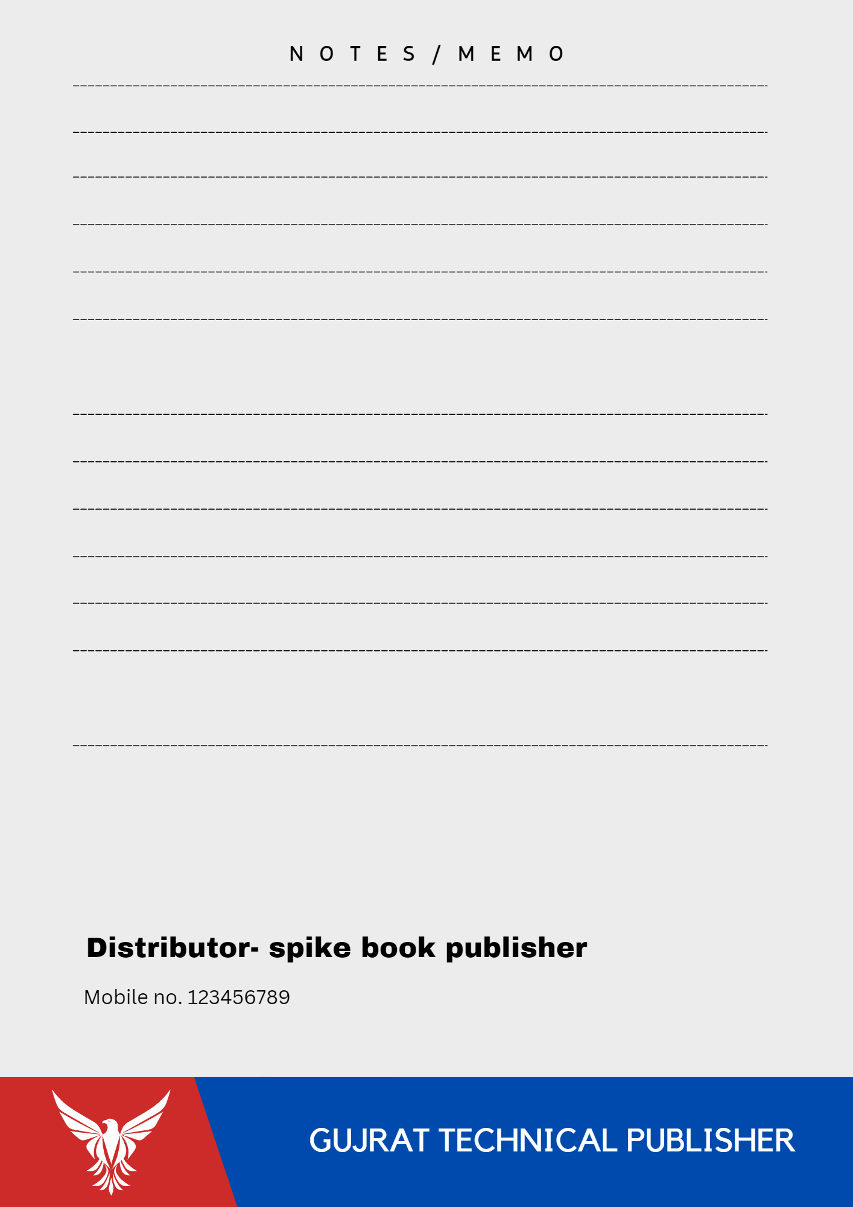PROJECT 9

DESIGN HAPPY BIRTHDAY MESSAGE USING WORD ART

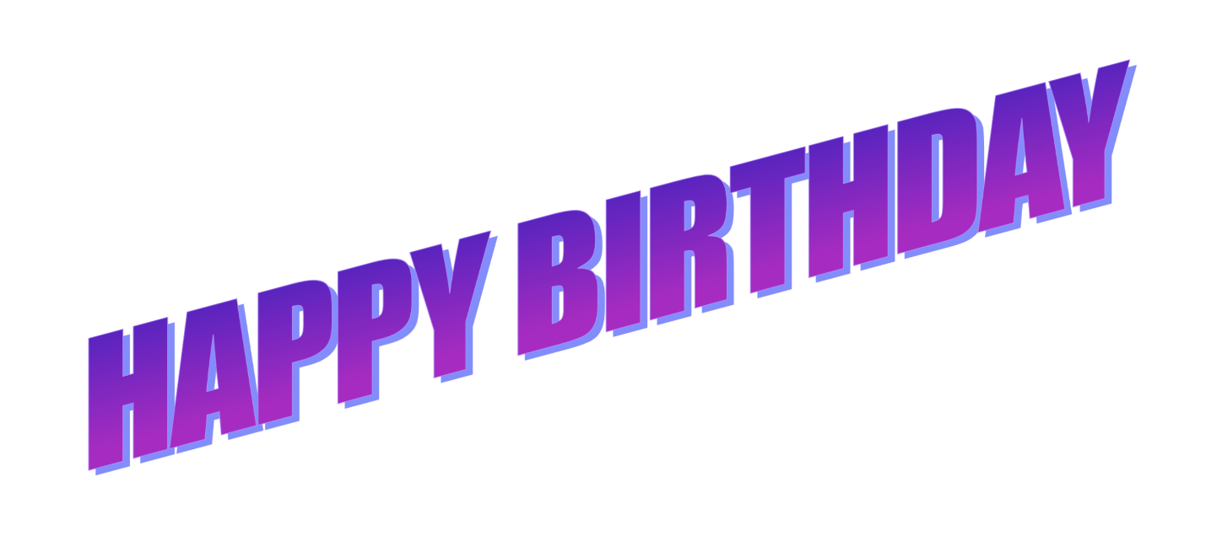

PROJECT 10

**DIGITAL NEWSPAPER ADVERTISEMENT**

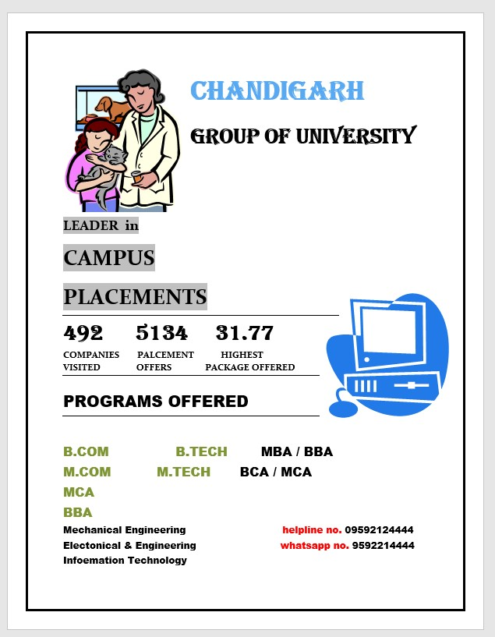

PROJECT 11

CREATE A CHART AND SHOW THE RESULTS COMPARISON BETWEEN 2019, 2020, AND 2021

PROJECT 12

**CREATE LETTER HEAD**

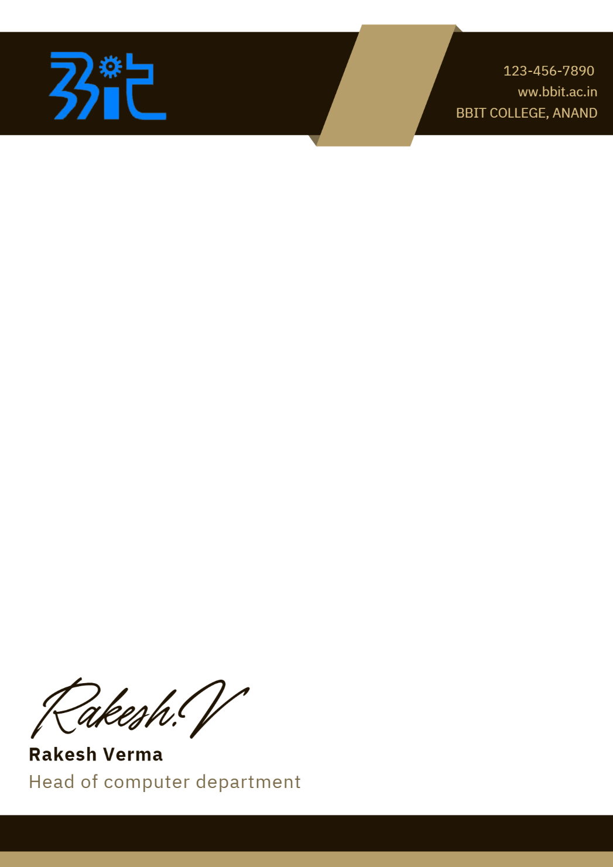

PROJECT 13

**CREATE RESUME**

